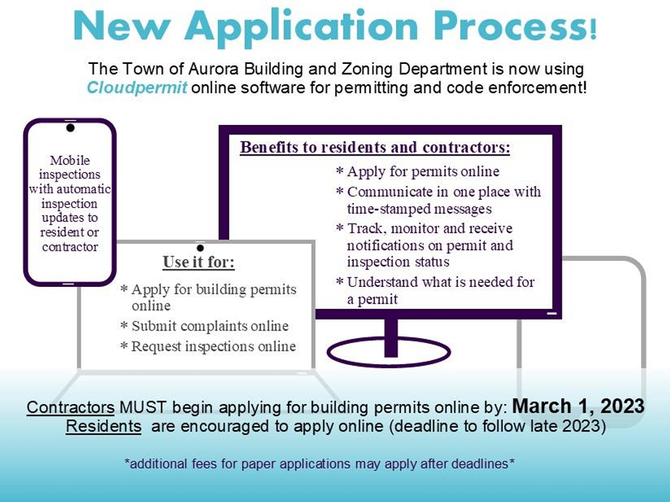

Log in/Create an account:
https://us.cloudpermit.com/login

Step by Step Guide How to Create an account:
https://support.cloudpermit.com/support/solutions/articles/67000648250-how-toregister-a-cloudpermit-account

How to submit an application:
https://support.cloudpermit.com/support/solutions/articles/67000710153-how-tosubmit-an-application

Applicant user guide:
https://support.cloudpermit.com/support/solutions/67000379492

TOWN OF AURORA
BUILDING DEPARTMENT
575 Oakwood Avenue, East Aurora, NY 14052
(716) 652-7591

PROCEDURE FOR DEMOLITION OF BUILDINGS

- Applicant submits completed Demo permit application consisting of the following:
  - Application and any required addendum
  - Survey of premises highlighting buildings(s) to be demolished
  - Proof of insurance – General Liability, Workers Compensation, and Disability showing the Town of Aurora/Village of East Aurora as Certificate Holder
  - A barricade plan detailing placement and height of fencing
  - Elevation map showing new grade.
  - Written verification that all utilities have been properly shut off and disconnected.
  - Permit to disconnect and cap sanitary, storm sewers and water shutoff. All work done must be under supervision of Village DPW for village property and ECWA for town property.
  - Fee paid - $50 (cash or check payable to the Town of Aurora)
  - Written verification from the property owner of date of building(s) will be demolished (received at least 24 hours in advance)
  - Short Environmental Assessment Form
- No work may commence until an asbestos report is completed and submitted to this office.
- All tanks (above and below ground) must be emptied, cleaned and removed
- Extermination of insects, pests, vermin, etc by a private exterminator, licensed by NYS Dept of Environmental Conservation, may be required when deemed necessary by the Building Inspector and/or Fire Inspector.
- Subsequent to demolition, all rubble, debris, etc. must be completely removed from the site and the site property secured for safety.
- Safety during demolition must conform to part 608 of NYS Uniform Fire Prevention and Building Code.
- East Aurora Police Department, 652-1111, needs to be contacted for traffic control.
- Department of Public Works, 652-6057 - water use for dust control.

SEE ATTACHED CHECKLIST

TOWN OF AURORA
BUILDING DEPARTMENT
575 Oakwood Avenue, East Aurora, NY 14052
(716) 652-7591

DEMOLITION PERMIT CHECKLIST

- ______ Demolition permit application and any addendum completed
- ______ Signature of property owner
- ______ Development Plan needed
- ______ Refer to East Aurora Historic Preservation Commission?
- ______ Survey submitted of property showing all building(s) to be demolished
- ______ Certificate of insurance – General Liability, Workers Compensation, and Disability
- ______ Barricade plan
- ______ New grades and type of fill indicated on survey
- ______ Utility lines disconnected:
    - Electric _____ Date _________
    - Gas _____ Date _________
    - Water _____ Date _________
    - Storm Sewer _____ Date _________
    - Sanitary Line _____ Date _________
- _____ Fee paid - $50
- _____ Written notification of dates for demolition
- _____ Asbestos survey
- _____ Tank removal
- _____ Extermination
- _____ East Aurora Police Dept notification
- _____ Department of Public Works notification
- _____ Short SEQR form

BUILDING DEPARTMENT
Town of Aurora/Village of East Aurora
575 Oakwood Avenue, East Aurora, NY 14052
Phone: (716)652-7591

APPLICATION FOR DEMOLITION/SUBSTANTIAL MODIFICATION

Property Owner Name: Phone #:

Property Address:

SBL #: Zoning District:

Applicant (if not the Owner): Phone #:
- Brief description of the demolition:
- Size of demolition (feet): ___ width ___ length ___ Height ____ Total sq. ft. or ☐ Entire Building/Structure
- Demolition Threshold (Village only): ☐ 30% (>2,501) ☐ 40% (1,201- 2,500) ☐ 50% (<1,200)
- Disconnection of services: ☐ Water ☐ Sewer ☐ Electric ☐ Gas ☐ N/A
- Asbestos Survey: ☐ Yes ☐ N/A – Age of Structure:
- Water use needed for dust control: ☐ Yes ☐ N/A
- General permit NYS DOT (state) or ECPW (county) street/road: ☐ Yes ☐ N/A
- Name of Contractor: Representative:

Address of Contractor:

Phone #: Email:
- Name of Asbestos Contractor: Representative:

Address of Contractor:

Phone #: Email:
- Contractor’s General Liability, Workers' Compensation, and Disability Insurance Certificates with the Town of Aurora & Village of East Aurora as Certificate holder: ☐ Yes ☐ N/A

IMPORTANT
- Site Plan or Survey showing lot and buildings on premises, relationship to adjoining premises or public streets or areas, and giving a detailed description of the layout of the property must be submitted with this application. Indicate the distance to the nearest building on the adjoining lot.
- A written report from a licensed exterminator regarding extermination must be submitted with the application, if applicable.
- Written verification that all utilities (i.e., gas, electric, water, and sewer) have been properly shut off and disconnected must be submitted with the application.
- No work may commence until an asbestos survey is completed and filed with the commissioner of the NYS Dept of Labor in accordance with the Industrial Code 56 and the rules and regulations of the Dept of Labor (submit a copy to this Dept)
- Debris, including any in-ground storage tanks, must be systematically removed from the site and not allowed to pile up or cause any obstruction.
- Demolition shall be carried out during daylight hours only on normal workdays.
- No explosives can be used in connection with the demolition of buildings or structures unless a special permit is first obtained by the Village Board of Trustees (village).
- All cellars and basements of demolished buildings or structures shall be filled in and made safe. The surface of the infill shall be level with the surrounding premises.

APPLICATION IS HEREBY MADE to the Code Enforcement Officer for the issuance of a Building Permit pursuant to the NEW YORK UNIFORM FIRE PREVENTION AND BUILDING CODE for the construction of buildings, additions, and alterations, as herein described. The applicant agrees to comply with all applicable codes, laws, and regulations. The undersigned hereby certifies that all of the information contained in this application is correct and true.

Owner Name: Email:

(Applicant or Corp/LLC must complete the affidavit on the next page to sign as the owner’s agent.)

Owner Signature: Date:

IF OWNER OF PROPERTY IS A CORPORATION, FILL IN LOWER SECTION

TO SIGN AS AGENT FOR PROPERTY OWNER:

IN ACCORDANCE WITH THE TOWN OF AURORA BUILDING CODE ORDINANCE (SECTION 65-8 B.2)

I, ,

STATE THE PROPOSED WORK IS AUTHORIZED BY THE PROPERTY OWNER AND I AM AUTHORIZED TO MAKE SUCH APPLICATION FOR A BUILDING PERMIT.

___________________________________________________

(Signature of Applicant)

STATE OF

COUNTY OF

TOWN

Sworn to before me this _____ day of ______________ 20___ Notary Seal

___________________________________________________

(Signature of Notary)

IF PROPERTY OWNER IS A CORPORATION, COMPLETE:

STATE OF NEW YORK

COUNTY OF ERIE ss

___________________________________ being duly sworn deposes and says that he is the applicant

(Name of individual signing application)

above named. He is the _______________________________________of said owner or owners, and

(Corporate Officer, etc.)

is duly authorized to perform or have performed the said work and to make and file this application: that all statements contained in this application are true to the best of his knowledge and belief, and that the work will be performed in the manner set forth in the application and in the plans and specifications filed therewith.

_________________________________________

(Signature of Applicant)

Sworn to before me this _____ day of ______________ 20___ Notary Seal

___________________________________________________

(Signature of Notary)

ADDENDUM TO APPLICATION FOR DEMOLITION/SUBSTANTIAL MODIFICATION

VILLAGE OF EAST AURORA ONLY

Where the Building Permit application has determined the proposed demolition and or substantial modification meets the thresholds set forth under Village Code §112-3 and requires the Demolition/Substantial Modification application, and or the Demolition/Substantial Modification application is for the demolition of the entire building/structure, the Village Board of Trustees must approve the demolition and or substantial modification application before the issuance of a demolition or building permit. To facilitate the review process, this application must be referred to the East Aurora Historic Preservation Commission (HPC).

The purpose of this addendum is to identify necessary information for the HPC to render its input as outlined in Village Code §112-5. This application and addendum should be accompanied by the construction documents that include the scope of demolition, the new exterior work, exterior finishes, and building/structure elevations, and photographs of the property where applicable. The complete application will be referred to the HPC at their next scheduled meeting, and the applicant and/or agent to the owner will be notified of the meeting. The HPC may require additional information or diligence beyond what is outlined in this addendum in the meeting.

The following reference sources may be of assistance in completing this addendum and may shorten the HPC’s review of your application: (i) Aurora Town Historian (www.townofaurorany.gov/departments/historian); (ii) your abstract of title; (iii) property file in Village Clerk’s office; (iv) real property tax records (www2.erie.gov/ecrpts); (v) Erie County Clerk’s Office. You are encouraged to consult with the Aurora Town/Village Historian to investigate the property's historical use and significance, both of which are required in this application.

NOTE: This addendum is not intended to be used if the property in question is a local landmark or is within a historic district as designated under Village Code Chapter 156. If a property is so designated, then the property owner must submit to the HPC an Application for Certificate of Appropriateness. This form and instructions are available on the Village website.

Provide information as follows to the best of your knowledge.

Year of Construction:

If architect designed, name of architect:

Names of original and subsequent owners, and dates of ownership, if known:

What is the historic use of the property?

To the best of your knowledge, is there any historic significance associated with the property? ☐Yes or ☐No

If yes, please explain:

Did you consult with the Aurora Town/Village Historian about the property’s historical use and historical significance? ☐Yes or ☐No

Applicant hereby certifies that, to the best of Applicant’s knowledge, information, and belief, the information set forth above is accurate and complete.

Applicant’s Signature: Date:

