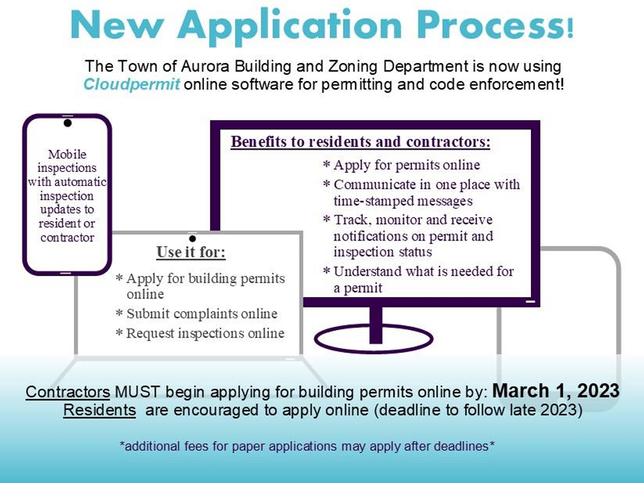

Log in/Create an account:
https://us.cloudpermit.com/login

Step by Step Guide How to Create an account:
https://support.cloudpermit.com/support/solutions/articles/67000648250-how-toregister-a-cloudpermit-account

How to submit an application:
https://support.cloudpermit.com/support/solutions/articles/67000710153-how-tosubmit-an-application

Applicant user guide:
https://support.cloudpermit.com/support/solutions/67000379492

TOWN OF AURORA
BUILDING DEPARTMENT
575 Oakwood Avenue, East Aurora, NY 14052
(716) 652-7591 FAX (716) 652-3507

SUBMITTAL REQUIREMENTS FOR A BUILDING PERMIT
(Construction other than a new dwelling)

Additions, Alterations-Renovations, Accessory Buildings (garage, pole barn, shed, etc.), Accessory Structures (deck, carport, pergola, etc.):

- Completed and signed Building Permit Application
- Completed Plan Review Cover Sheet.
- Completed Accessibility form (commercial permit applications only).
- Survey or plot plan, drawn to scale, showing all existing structures on the site, distances from lot lines, well and septic locations; show location of proposed work.
- Set of Plans of proposed improvement (floor plan, elevations, basement, materials, structural, mechanical and electrical work as applicable)
*For Additions: signed and sealed by NYS licensed Architect/Engineer
(Any amendments to #4 or #5 must be filed prior to the completion of the work, subject to the approval of Building Department officials)
*For pre-built sheds: provide a brochure or bill of sale showing or describing the framing of the structure.
*For accessory structures over 24’x24’: signed and sealed by NYS licensed Architect/Engineer.
- General Liability, Worker’s Comp and Disability Insurance Certificates of Contractor
- Additional items if applicable:
  - Energy Audit/Statement aka REScheck (if living space)
  - Carbon monoxide alarm installed on any story having a sleeping area and where there is a fuel-fired appliance or equipment
  - Truss sheets
  - SWPPP/Notice of Intent/Erosion & Sediment control (if disturbing over 1 acre)

Fence, Generators:

- Completed and signed Building Permit Application
- Copy of property survey, showing all existing structures on the site, proposed location of the generator/fence.
- Generator specifications showing required clearances
- Fence specifications (height, materials, etc.)
(see Town/Village forms for fence height, other requirements)
- General Liability, Worker’s Comp and Disability Insurance Certificates of Contractor

APPLICATION FOR SOLID FUEL BURNING APPLIANCE
(i.e. Fireplace, wood stove, inserts, etc)
All solid fuel burning appliances require a separate permit. Prior to processing an installation application, a copy of the manufacturer’s installation instructions for unit and chimney must be submitted to the Building office.

**see below for submittal requirements pertaining to Demo work, Pools, Ponds, Signs, and Solar Installations *
BUILDING DEPARTMENT
Town of Aurora/Village of East Aurora
575 Oakwood Avenue, East Aurora, NY 14052
Phone: (716)652-7591

Permit Renewal:

APPLICATION FOR BUILDING PERMIT

Please select one: See the separate applications for: sign, pond, pool, and solar permits.

Occupancy classification: ☐ one or two-family dwelling ☐ commercial (including multi-family dwelling)

Permit type: ☐ New Building ☐ Addition ☐ Alteration ☐ Fence

☐ Accessory Structure ☐ Generator ☐ Other:

Property Owner Name: Phone #:

Property Address:

SBL #: Zoning District:

Applicant (if not the owner): Phone #:
- Brief description of the scope of work:
- Size of scope of work (feet): ____ width ____ length ____ Height ____ Total sq. ft. ____ linear feet (fence)
- Demolition/Substantial Modification in association with a building permit for alteration or addition:

Village of East Aurora only - Where the threshold exceeds the value below based on the dwelling/structure size, and/or a “yes” is determined, complete the separate Demolition/Substantial Modification permit application. Village Code §112-3.

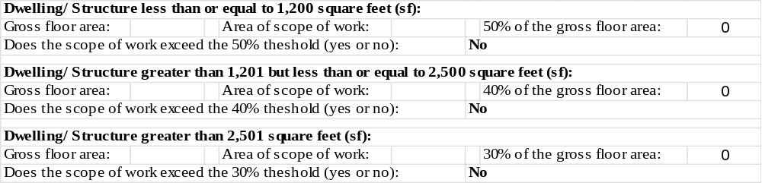
- Construction cost:
- Electrical Inspection(s) by an approved Third-Party agency by the Town of Aurora: ☐ Yes ☐ N/A
- DPW Action Required: ☐ Water Tap ☐ Sewer Tap ☐ Backflow Preventer ☐ Grease Trap
- Name of Contractor: Representative:

Address of Contractor:

Phone #: Email:
- Name of Architect: Representative:

Address of Architect:

Phone #: Email:

IMPORTANT
- The work covered by this application may not be commenced before the issuance of the Building Permit.
- No building shall be occupied or used in whole or in part for any purpose whatsoever until the Building Department shall have granted a Certificate of Occupancy.

APPLICATION IS HEREBY MADE to the Code Enforcement Officer for the issuance of a Building Permit pursuant to the NEW YORK UNIFORM FIRE PREVENTION AND BUILDING CODE for the construction of buildings, additions, and alterations, as herein described. The applicant agrees to comply with all applicable codes, laws, and regulations. The undersigned hereby certifies that all of the information contained in this application is correct and true.

Owner Name: Email:

(Applicant or Corp/LLC must complete the affidavit on the next page to sign as the owner’s agent.)

Owner Signature: Date:

IF OWNER OF PROPERTY IS A CORPORATION, FILL IN LOWER SECTION

TO SIGN AS AGENT FOR PROPERTY OWNER:

IN ACCORDANCE WITH THE TOWN OF AURORA BUILDING CODE ORDINANCE (SECTION 65-8 B.2)

I, ,

STATE THE PROPOSED WORK IS AUTHORIZED BY THE PROPERTY OWNER AND I AM AUTHORIZED TO MAKE SUCH APPLICATION FOR A BUILDING PERMIT.

(Signature of Applicant)

STATE OF

COUNTY OF

TOWN

Sworn to before me this day of 20 Notary Seal

(Signature of Notary)

IF PROPERTY OWNER IS A CORPORATION, COMPLETE:

STATE OF NEW YORK

COUNTY OF ERIE ss

being duly sworn deposes and says that he is the applicant

(Name of individual signing application)

above named. He is the of said owner or owners, and

(Corporate Officer, etc.)

is duly authorized to perform or have performed the said work and to make and file this application: that all statements contained in this application are true to the best of his knowledge and belief, and that the work will be performed in the manner set forth in the application and in the plans and specifications filed therewith.

(Signature of Applicant)

Sworn to before me this day of 20 Notary Seal

(Signature of Notary)

